Date: 13-12-23

**SQL ASSESSMENT**

**Question**:

1.Querying Data by Using Joins and Subqueries.

2.Manipulate data by using SQL commands using group by and having clause.

**Solution:**

Creating two tables name product and department.

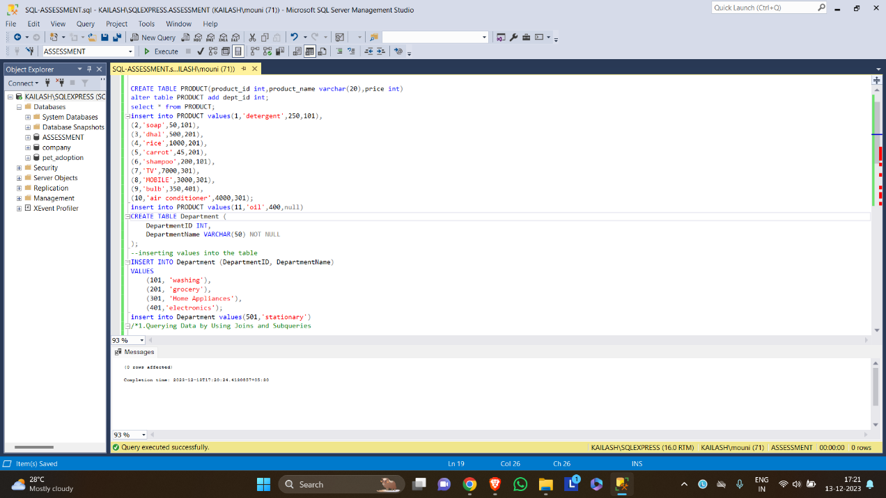

1.Using joins for the two tables product and department with department id as common.

Using subquery to find products in a particular department.

Using both join and subquery to find high pricing product with department name.

2. Using group by to find average price of each department.

Using having clause to find department with more than 2 products.

Using some DML commands like select, create, insert and delete. Insert and create are used to create the tables(page1).

